CUBE ERP - laravel upgrade strategy and maintenance policy (policy)



Document ID | DigDev_Cube_Laravel_Upgrade_Strategy_(Policy)_v1.0
Product | CUBE
Environment | ALL
Confidentiality Level | Internal / Restricted

Contents
1 DOCUMENT INFORMATION 3
1.1 Validation 3
1.2 Document Distribution 3
1.3 Version Control 3
2 PURPOSE & CONTEXT 4
2.1 About this document 4
2.2 Scope 4
2.3 Roles & Responsibilities 4
2.4 Terminology 4
2.5 Conventions Used 5
3 laravel upgrade context 6
3.1 Laravel upgrade methods 6
3.1.1 Boost Command 6
3.1.2 Laravel Shift 6
3.2 Laravel Shift Overview 6
3.2.1 Laravel Shift Process 6
3.3 Laravel Shift Usage Policy 7
3.4 Boost Command Upgrade Approach 7
3.4.1 Boost Command Usage Policy 7
4 Recommended Hybrid Plan 8
4.1 Step by step plan 9
4.2 Microservice-Based Upgrade Approach 9
5 Upgrade Execution Process 10
5.1 Preparation 10
5.2 Upgrade Execution 10
5.3 Review 10
5.4 Validation 10
5.5 Merge and Deployment 11
5.6 Rollback Planning 11
5.7 Version Control and CI Enforcement 11
6 POLICY APPROVAL SIGNATURES 12

DOCUMENT INFORMATION

Validation
Name |  | Role | Date (dd/mm/aa)
Issued by | Oscar Rondon | Technical Writer | 01/05/2026
Verified by | Dhaval Patel | Developer | 01/05/2026
Approved by | Anthony Bures | Digital Development Manager | 01/05/2026

Document Distribution
Normal | Role
Oscar Rondon | Technical Writer
Dhaval Patel | Developer
Anthony Bures | Digital Development Manager

Version Control
Version | Date | Author | Description of changes
1.0 | 01/05/2026 | Oscar Rondon | 1st Version of the Cube Laravel Upgrade Strategy

PURPOSE & CONTEXT

About this document
This document defines the long-term Laravel upgrade strategy for CUBE ERP at ZTERS. The purpose of this policy is to establish a sustainable, repeatable, and controlled approach for keeping all Laravel-based CUBE ERP services updated over time.
The strategy focuses on preventing system-wide disruption by supporting incremental upgrades, aligned with the intended microservices architecture of CUBE ERP. Rather than upgrading the full system as a single large effort, Laravel upgrades should be planned, executed, reviewed, and validated service by service.
This document also provides guidance on available upgrade methods, recommended planning practices, and the recurring process required to keep Laravel versions current across the CUBE ERP environment.

Scope
This policy applies to all Laravel-based services, modules, or microservices that are part of the CUBE ERP ecosystem at ZTERS.
In scope:
- Laravel version documentation.
- Upgrade cycle planning.
- Microservice-based Laravel upgrade execution.
- Review and validation of automated upgrade changes.
- Use of Laravel upgrade tools.
- Upgrade scheduling and recurring maintenance planning.
Out of scope:
- Define detailed application-specific business logic changes unless those changes are required as part of a Laravel upgrade.

Roles & Responsibilities
Role | Responsibilities
Development T eam | Execute Laravel upgrades, review code changes, resolve upgrade issues, and validate services.
Technical Lead | Approve upgrade approach and confirm alignment with CUBE ERP architecture decisions.
QA / Validation Team | Validate affected workflows and confirm that upgraded services behave as expected.
DevOps | Support CI checks, deployment, rollback, and environment readiness.
Documentation Owner | Maintain this policy and update upgrade records, schedules, and lessons learned.

Terminology
Term Used | Description
CUBE ERP | The internal ERP system used by ZTERS to support operational and business processes.
Laravel | The PHP framework used to build Laravel-based services within CUBE ERP.
Laravel Upgrade | The process of updating a Laravel-based service from its current Laravel version to a newer supported version.
Laravel Shift | A paid automated Laravel upgrade service that connects to a repository and creates a pull request with atomic, reviewable commits.
Boost Command | A CLI-based upgrade approach using the /upgrade-laravel-v13 command to support Laravel upgrade work locally.
Rector | A code transformation tool that can help apply reusable upgrade rules and automate recurring code changes.
Composer | The dependency manager used by Laravel/PHP applications to manage packages and framework dependencies.
Composer Audit | A dependency audit process used to identify known security vulnerabilities or package issues in Composer-managed dependencies.
Microservice | An independently maintained service within the CUBE ERP architecture that can be upgraded, tested, and deployed separately when supported by the architecture.
Modular Upgrade | An upgrade approach where Laravel services are updated incrementally instead of upgrading the entire system at once.
Pilot Service | The first selected service used to test and validate the upgrade approach before applying the process to other services.
Auth Service | The recommended pilot service for the initial Laravel upgrade strategy, based on the provided planning notes.
Pull Request | A proposed code change submitted for review before being merged into the main codebase.
Atomic Commit | A small, focused commit that contains one clear change, making upgrade work easier to review and understand.
CI | Continuous Integration, a development process where automated checks are run to validate code changes before merge or deployment.
Version Drift | A situation where services fall behind current framework or dependency versions over time, making future upgrades larger and riskier.
Rollback | The process of reverting an upgraded service to a previous stable version when a deployment or upgrade causes issues.

Conventions Used
The following structures are used as recommendations.
Info: Supplementary Information

Tip: A recommendation or useful advice

Warning: A warning or important notice

Note: A notice.

laravel upgrade context
CUBE ERP requires a long-term upgrade approach for Laravel-based services. The strategy must account for the current Laravel version used by each service and define a repeatable upgrade cycle.

Laravel upgrade methods
There are two identified methods for performing Laravel upgrades in CUBE ERP:

Boost Command
- Command: /upgrade-laravel-v13
- Used as a CLI-based upgrade approach.
- Runs locally.
- Does not require repository access from an external service.
- Provides control over each change.
- Requires manual review and manual diff validation.

Laravel Shift
- Paid automated upgrade service.
- Connects to a GitHub or Bitbucket repository.
- Opens a pull request with atomic, reviewable commits.
- Automates parts of the Laravel upgrade process.
- May cover undocumented breaking changes beyond the official upgrade guide.
- Still requires manual review and validation after the pull request is created.

Laravel Shift Overview
Laravel Shift is an automated service that supports Laravel upgrades by creating a pull request with clean, atomic commits. The pull request can then be reviewed by the development team before merging.
Laravel Shift may help reduce manual upgrade effort, especially during the first upgrade or pilot upgrade, because it identifies and applies common upgrade changes automatically.

Laravel Shift Process
The Laravel Shift process works as follows:
- Connect the Repository
Sign in with GitHub or Bitbucket and authorize Laravel Shift to access the repository.
- Choose the Shift
Select the target Laravel version for the upgrade. The available plan depends on the current Laravel version and the target version.
- Automated Upgrade Execution
Laravel Shift clones the repository, updates composer.json, bumps first-party and popular community packages, and applies code changes based on the conventions of the target Laravel version.
- Pull Request Creation
Laravel Shift opens a pull request with atomic, reviewable commits.
- Manual Review and Completion
The development team reviews the pull request and handles any remaining manual work, including business logic, custom packages, and changes that Laravel Shift could not automate.

Laravel Shift Usage Policy
Laravel Shift may be used as a support tool for Laravel upgrades, but it must not be treated as a fully automatic replacement for developer review.
Any pull request generated by Laravel Shift must be reviewed before approval. The team must validate that the upgraded service continues to meet functional, technical, and business requirements.

Boost Command Upgrade Approach
The upgrade-laravel-v13 Boost command is a CLI-based upgrade option that can be used to perform Laravel upgrades locally.
This method provides full control over every change and does not require external repository access. However, it requires the development team to manually review diffs, validate changes, and identify anything not automatically handled by the command.

Boost Command Usage Policy
The Boost command may be used when:
- The team wants to run the upgrade locally.
- External repository access is not preferred.
- Cost must be minimized.
- The service can be upgraded manually with internal review.
- The team already understands the required upgrade patterns from a previous pilot upgrade.

Recommended Hybrid Plan
For CUBE ERP, the recommended approach is a hybrid upgrade strategy.
The hybrid strategy uses Laravel Shift as a learning and acceleration tool for one pilot service, then applies the patterns identified from that upgrade to the remaining services using the free CLI-based approach.
This allows the team to benefit from Laravel Shift’s automation while avoiding the cost of applying the paid service to every CUBE ERP service.
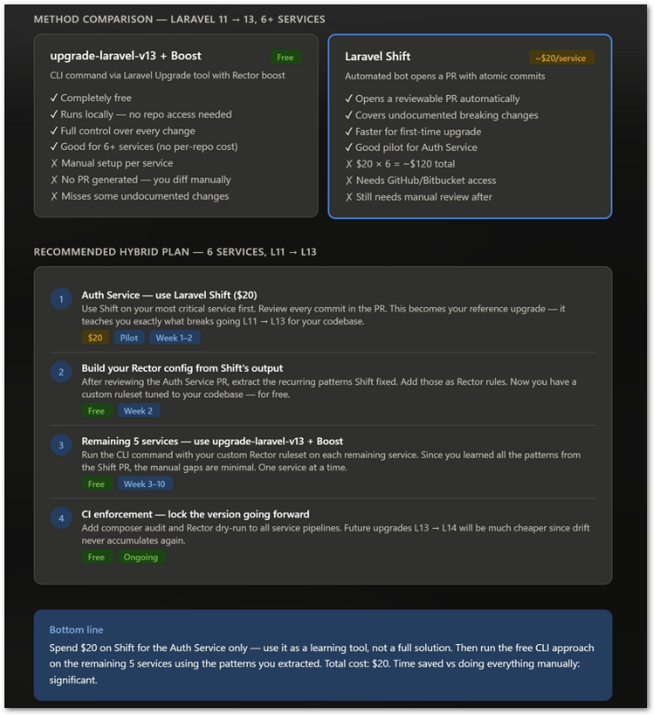

Step by step plan
Step | Activity | Tool / Method | Timing
1 | Upgrade the Auth Service as the pilot service. | Laravel Shift | Week 1–2
2 | Review the Laravel Shift pull request and identify recurring upgrade patterns. | Manual review | Week 1–2
3 | Build or refine Rector rules based on the upgrade patterns found in the pilot service. | Rector configuration | Week 2
4 | Apply the CLI-based upgrade approach to the remaining services. | upgrade-laravel-v13 + Boost | Week 3–10
5 | Upgrade one remaining service at a time. | Incremental service upgrade | Week 3–10
6 | Add Composer audit and Rector dry-run checks to service pipelines. | CI enforcement | Ongoing
7 | Continue recurring upgrade planning for future Laravel versions. | Scheduled review process | Ongoing

Microservice-Based Upgrade Approach
Laravel upgrades for CUBE ERP should follow a microservice-based approach. Each Laravel service should be evaluated and upgraded independently whenever possible. This approach supports the following principles:
- Upgrade one service at a time.
- Avoid forcing all services to upgrade in the same deployment window.
- Reduce the risk of full-system disruption.
- Validate each service independently before moving to the next one.
- Use lessons learned from one service to improve the next upgrade.
- Maintain upgrade visibility through version tracking and planning documentation.

Upgrade Execution Process
Each Laravel service upgrade should follow the process below.

Preparation
Before starting the upgrade, the development team should:
- Confirm the service name and repository.
- Document the current Laravel version.
- Confirm the target Laravel version.
- Review service dependencies.
- Identify custom packages or business logic areas that may require manual review.
- Select the upgrade method.
- Create a dedicated upgrade branch.

Upgrade Execution
The upgrade should be executed using the selected method:
- Laravel Shift, if the service is selected for paid automated upgrade support.
- Boost command, if the upgrade is being performed locally.
- Rector rules, if reusable upgrade patterns have already been identified.
Automated changes must be reviewed before merging.

Review
The review should confirm that:
- composer.json changes are understood.
- Package version changes are acceptable.
- Automated code changes are valid.
- Business logic has not been unintentionally changed.
- Custom packages still work as expected.
- The service can run successfully after the upgrade.

Validation
Each upgraded service must be validated before approval. Validation should include, where applicable:
- Local execution checks.
- Automated test execution.
- API or service-level testing.
- Regression testing for affected workflows.
- Dependency compatibility review.
- Review of application logs.
- Confirmation that no critical functionality was disrupted.

Merge and Deployment
The upgrade branch may only be merged after review and validation are completed.
Deployment should follow the standard CUBE ERP release process.

Rollback Planning
Each Laravel upgrade must include a rollback plan before deployment. The rollback plan should define:
- The branch or release version to restore.
- The deployment rollback procedure.
- Any database or configuration considerations.
- The person or team responsible for rollback execution.
- The criteria for deciding when rollback is required.
Rollback should be considered if:
- The upgraded service fails to start.
- Critical workflows stop working.
- Integration behavior is disrupted.
- Production-impacting errors appear after deployment.
- The issue cannot be resolved safely within the deployment window.

Version Control and CI Enforcement
To prevent future version drift, Laravel upgrade controls should be added to the development and CI process. Recommended controls include:
- Composer audit checks.
- Rector dry-run checks.
- Pull request review requirements.
- Upgrade branch naming conventions.
- Required validation before merge.
- Service-level Laravel version tracking.
These controls should help ensure that future Laravel upgrades are smaller, more frequent, and easier to manage.

POLICY APPROVAL SIGNATURES
Digital signature blocks below are formatted for DocuSign / Adobe Sign.
Name | Role | Digital Signature Block | Date (dd/mm/aa)
Oscar Rondon | Technical Writer |  | 30/04/2026

--- END OF THE DOCUMENT ---

